Alex Mitchell

Sound Board Project Final Paper

ECE 428 Embedded Systems

5/6/21

**Introduction:**

This paper will go over the basic construction of my embedded system project. This project is, in essence, a sound board or stream deck. It can play sounds that you have pre recorded, as well as sounds that you can record live. The pre recorded sounds’ volumes are adjustable. This project also drives a stream of individually controllable LEDs. The colors displayed by these LEDs are adjustable as well.

This paper will contain the following:

**A part list:** All parts used in this project will be listed, the number used is variable and dependent on what the end user wants from their device.

**Circuit Diagrams:** A pair of diagrams are included, showing how each device can be connected to the arduino.

**Code:** The actual code is not included here, but a link to the GitHub repository with the code, as well as other files associated with this project, has been included.

**Libraries:** A basic breakdown of what each included library does is also included in this paper. This is to help users decide which libraries they would like to use in their own versions of this project. Alternative libraries likely exist, but these are the ones recommended by me, and by the developer of the DF Player mini.

**Part List:**

Arcade buttons (any brand will work)

Arduino Uno

Bread board

CQRobot Speaker (very good speaker for about $2.00)

DF Player mini

ISD1820 (two were used for the purposes of this project)

Jumper wires (all types, mostly male to male)

Potentiometers (10k recommended, but not required)

Resistors (10 ohm, 1k ohm, and 10k ohm)

WS2812B strip (once again, any brand will do, I used 30 LEDs [0.5 meters] for this project)

**Circuits:**

In order to keep the circuit diagram below simple and legible, only the wiring for major components, or wiring that is less intuitive is shown. Components shown are the ISD1820, DF Player mini, and the speaker.

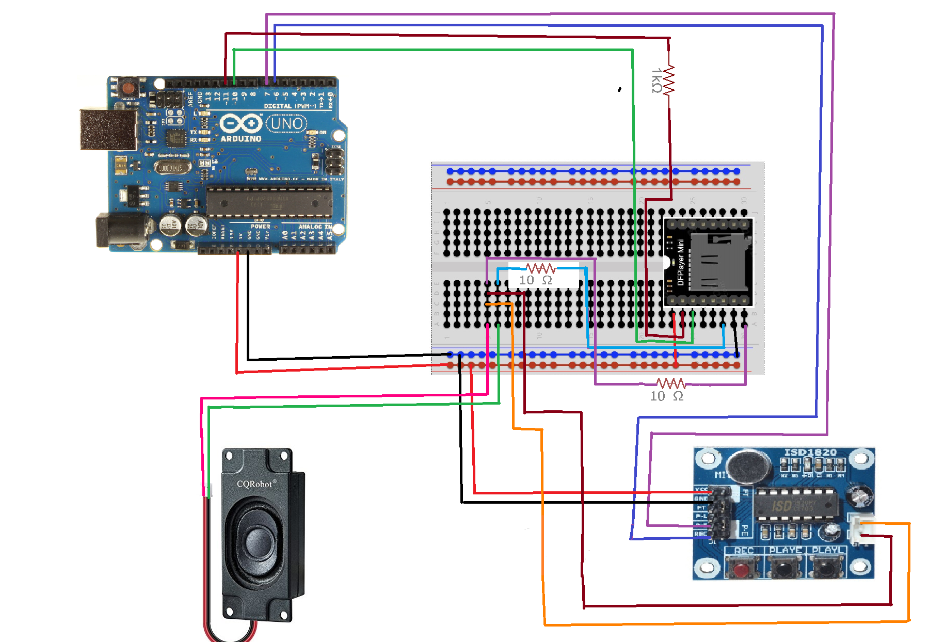

This second diagram shows all of the components that were not shown in the diagram above. Shown wired is a button, a potentiometer, and the WS2812B LED strip.

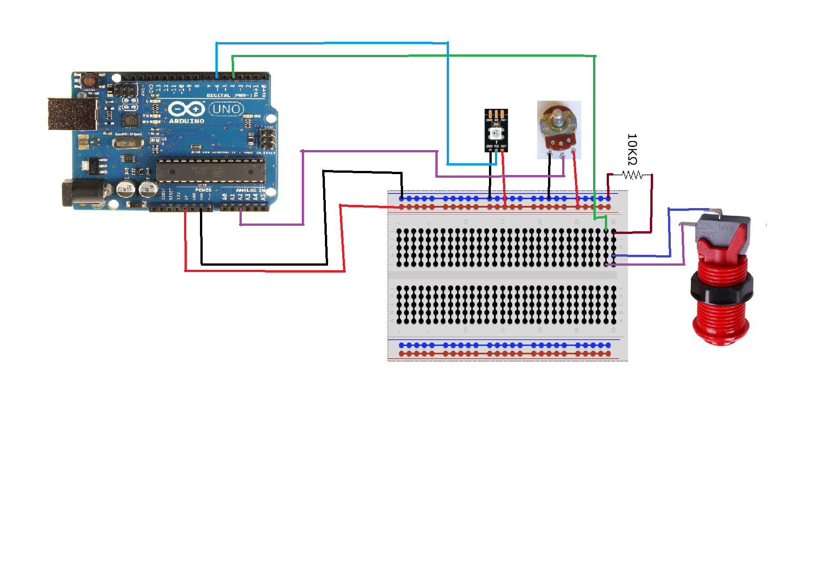

**Code:**

All code, as well as the poster, powerpoint, and this paper are in my GitHub.

The associated username is: agmitchell-coder

The associated project name is: Embedded-Project

Link to this project.

<https://github.com/agmitchell-coder/Embedded-Project.git>

**Libraries:**

This project uses three code libraries, I will name them and outline what they are used for below.

**SoftwareSerial** and **DFRobotDFPlayerMini**: These two libraries are used to declare and drive the DF Player mini. It also runs several serial print messages, as recommended by the developer, to help with later bug testing. These print messages can, however, be removed.

**FastLED**: This library is used to declare and then drive the WS2812B LED strip. It does everything from declaring the number of LEDs, to controlling their patterns and color levels.